**Design Thinking: A Quick Overview**

BY [**RIKKE FRIIS DAM**](https://www.interaction-design.org/literature/author/rikke-1) AND [**YU SIANG TEO**](https://www.interaction-design.org/literature/author/teo) | 3 WEEKS AGO | 6 MIN READ

**150**SHARES

93

46

11

*If you have just started embarking your journey through the*[*Design Thinking*](https://www.interaction-design.org/literature/topics/design-thinking)*process, things might seem a little overwhelming. This is why we have prepared a useful overview of the Design Thinking process, as well as some of the popular Design Thinking frameworks commonly used by global design firms and national design agencies.*

To begin, let’s have a quick overview of the fundamental principles behind Design Thinking:

* Design Thinking **starts with empathy**, a deep human focus, in order to gain insights which may reveal new and unexplored ways of seeing, and courses of action to follow in bringing about preferred situations for business and society.
* It involves **reframing the perceived problem or challenge** at hand, and gaining perspectives, which allow a more holistic look at the path towards these preferred situations.
* It encourages **collaborative, multi-disciplinary teamwork** to leverage the skills, personalities and thinking styles of many in order to solve multifaceted problems.
* It initially employs **divergent styles of thinking to explore as many possibilities**, deferring judgment and creating an open ideations space to allow for the maximum number of ideas and points of view to surface.
* It later employs **convergent styles of thinking to isolate potential solution streams**, combining and refining insights and more mature ideas, which pave a path forward.
* It engages in **early exploration** of selected ideas, rapidly modelling potential solutions to encourage **learning while doing,** and allow for gaining additional insight into the [viability](https://www.interaction-design.org/literature/topics/viability) of solutions before too much time or money has been spent
* **Tests the prototypes** which survive the processes further to remove any potential issues.
* **Iterates** through the various stages, revisiting empathetic frames of mind and then redefining the challenge as new knowledge and insight is gained along the way.
* It **starts off chaotic** and cloudy steamrolling towards points of clarity until a desirable, feasible and viable solution emerges.

As we have seen from the definitions and descriptions, Design Thinking means many things to many people, and this theme persists into the practical implementation as well. There are a wide variety of process [breakdowns](https://www.interaction-design.org/literature/topics/breakdowns) and visualisations ranging typically between 3 and 7 steps. Each process step or phase embodies one or more of the core ingredients of design thinking that being, reframing, [empathy](https://www.interaction-design.org/literature/topics/empathy), [ideation](https://www.interaction-design.org/literature/topics/ideation), [prototyping](https://www.interaction-design.org/literature/topics/prototyping) and testing. These different implementation frameworks or models might have different names and number of stages, but they embody the same principles laid out in the bullet points above.

**Modelled on Early Traditional Design Processes**

The earliest process expressions of Design Thinking were almost exact replications of the traditional [Design Process](https://www.interaction-design.org/literature/topics/design-process), with the later addition of deeper empathy and more specific forms multidisciplinary collaboration. Taken from Herbert Simon's 1969 seminal work *The Sciences of the Artificial,*the design process: *define, research, ideate, prototype, choose, implement*, and *learn* has been the cornerstone of design process for decades.

**Popular Design Thinking Frameworks**

**Heart, Head and Hand**

The Design Thinking Process is a blend of **Heart, Head and Hand**. This means the process is based on vision, need, [emotion](https://www.interaction-design.org/literature/topics/emotion) and feeling to begin with, continuing on to the cognitive processing for ideation and evaluation and then diving into practical creation by hand. It's a holistic process and demands input from all of our faculties in order to be successful.

**Deep-Dive**

The Deep-Dive was IDEO'S first expression of this process, which they aired LIVE on ABC Nightline back in the late 90's. The Deep-Dive process comprises of the following steps:

* Understand
* Observe
* Visualise
* Evaluate
* Implement

Deloitte acquired the Deep-Dive process in 2006.

**d.school’s 5 Stage Process**

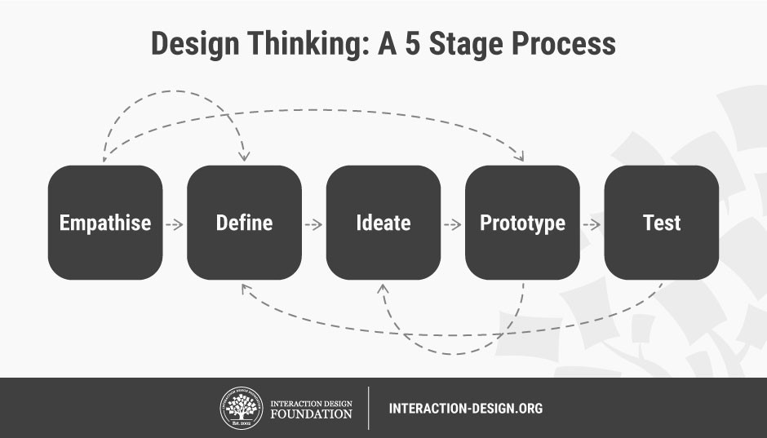Author/Copyright holder: Teo Yu Siang and [Interaction Design](https://www.interaction-design.org/literature/topics/interaction-design) Foundation. Copyright terms and licence: CC BY-NC-SA 3.0

The Stanford Design School (d.school), now known as the Hasso Plattner Institute of Design began teaching a design thinking process with the following 3 steps:

* Understand
* Improve
* Apply

They have since moved on to formulate and open source their famous 5 stage process below which is widely used. This is the process we also recommend:

1. Empathise
2. Define
3. Ideate
4. Prototype
5. Test

The d.school represents the 5 stage process by their hexagonal Design Thinking Lenses. The lenses are purposely defined as such so they will be seen more as enablers or modes of thinking, rather than concrete linear steps.

**IDEO’s Design Thinking Process**

IDEO uses a different process, and while it has only three stages, covers pretty much the same ground as the other processes covered here. The three stages are

* Inspire: The problem or opportunity that motivates the search for solution
* Ideate: The process of generating ideas
* Implement: The path that leads form the project room to the market

IDEO have also released a deck of IDEO Method Cards covering the modes **Learn, Look, Ask, Try** each with their own collection of methods for an entire [innovation](https://www.interaction-design.org/literature/topics/innovation) cycle.

**HCD - Human Centred Design**

IDEO has also developed contextualised toolkits, which repackaged the Design Thinking processes. One such iteration focuses on the social innovation setting in developing countries. For this context the terminology needed to be simplified, made memorable and restructured for the typical kinds of challenges faced. The HCD process (Human Centred Design) was re-interpreted as an acronym to mean Hear, Create, Deliver.

**H: Hear**

Similar to early phases in other Design Thinking processes, the Hear stage is about developing an empathic understanding of users, as well as [defining the problem](https://www.interaction-design.org/literature/topics/defining-the-problem) that the team is trying to solve. It serves the purpose of gaining a solid foundation in the context of the problem and sufficiently reframing it in order to progress. In this phase of the process, design thinkers need to

* identify their challenge,
* recognise existing knowledge in the challenge space,
* identify people to engage with to understand the deeper human side of the challenge,
* engage in a range of [ethnographic research](https://www.interaction-design.org/literature/topics/ethnographic-research) activities to uncover sufficient human insight, and
* develop Points of view or stories to guide the creation phase.

**C: Create**

Similar to the Ideate and Prototype phases in d.school’s 5-stage approach, the Create stage here is concerned with exploration, experimentation and learning through making. It involves pinpointing potential areas of exploration and then engaging those closest to the problem to co-create solutions. This allows design teams to maintain the highest levels of empathy during early design phases as well as weed out potential problematic [assumptions](https://www.interaction-design.org/literature/topics/assumptions) made by designers who do not sufficiently understand the context.

* Highlight Opportunities to explore from insights gained in the Hear Phase
* Recruit participants for the co-design task from a diverse pool of those affected
* Maintain awareness of sensitivities by avoiding judgements
* Encouraging [storytelling](https://www.interaction-design.org/literature/topics/storytelling) and expression
* Facilitate action orientated creation of tangible solution

**D: Deliver**

The Deliver phase of the HCD process is centred around logistical implementation and overcoming any obstacles which may exist when rolling out a solution within the required context. Though solutions arrived at may provide a functional patch to a problem, getting by in communities and bypassing any other roadblocks on the path of implementation is essential for the process to be completed successfully.

**Design Council of the UK: 4 D’s**

The Design Council of the UK has settled on 4 D's, Discover, Define, Develop, Deliver. They make use of a Double Diamond process diagram to indicate 2 cycles of divergent and [convergent thinking](https://www.interaction-design.org/literature/topics/convergent-thinking) and activities.

**Frog Design**

Frog Design's 3 D's Discover, Design Deliver has been replaced with Explore, Converge, Support, indicating a focus on more than just finite projects or products but an ongoing relationship with their clients well after delivery date.

**What x 4**

Jeanne Liedtka and Tim Ogilvie's book, *Designing for Growth*, puts forward a unique spin on the same journey, reframing the terminology into a more inquisitive and intuitive 4 W's. Jeanne Liedtka is a professor of business administration at the Darden School of the University of Virginia, while Tim Ogilvie is the founder of innovative consultancy firm Peer Insight, and both are experts in design thinking and strategic thinking. Their 4 W’s process involves asking:

* **What is?**Exploring the current reality
* **What if?**Envisioning Alternative Futures
* **What wows?** Getting users to help us make some tough choices
* **What works?** Making it work in-market, and as a business

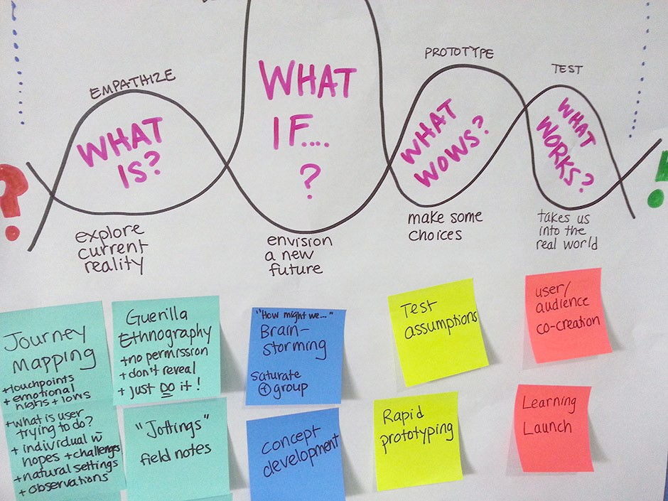Author/Copyright holder: Christine Prefontaine. Copyright terms and licence: CC BY-SA 2.0

*What if—one of the most powerful phrases in the English language, and for good reason.*

**The LUMA System**

The LUMA Institute, a global firm that teaches innovation and human-centred design, has its own expression of Design [Thinking modes](https://www.interaction-design.org/literature/topics/thinking-modes): Looking, Understanding and Making. This unfolds through a series of steps per mode completed with a proprietary user manual and method cards. The modes allow for remixing a wide range of processes through the 3 modes using methods specific to your needs.

**The Take Away**

We could spend weeks exploring the Design Thinking Processes, their differences and similarities and the merits of variety or conformity. It is important for us to peel away the facade in order to understand the foundations. To the first timer, at first sight, the Design Thinking process is mysterious, chaotic, and at many times complex. However, it's a discipline, which will grow on you with direct practice. You will learn things in a practical manner, which no theory can adequately cover growing in confidence with each new experience. You may even be tempted to develop your own expression of these steps, modes, and phases to suite a completely new context, and that's part of the beauty of Design Thinking.

**References & Where to Learn More**

Herbert Simon, *The Sciences of the Artificial*, 1969: <https://monoskop.org/images/9/9c/Simon_Herbert_A_The_Sciences_of_the_Artificial_3rd_ed.pdf>

Deloitte, *Deep diving for innovation*, 2011: <http://globalblogs.deloitte.com/deloitteperspectives/2011/10/deep-diving-for-innovation.html>

d.school, *The Design Thinking Process*: [http://dschool.stanford.edu/redesigningtheater/the-design-thinking-process/](https://dschool-old.stanford.edu/sandbox/groups/designresources/wiki/36873/attachments/74b3d/ModeGuideBOOTCAMP2010L.pdf?sessionID=573efa71aea50503341224491c862e32f5edc0a9)

Tim Brown, *Design Thinking for Social Innovation*, 2010: <https://ssir.org/articles/entry/design_thinking_for_social_innovation>

IDEO, *Method Cards*: <https://www.ideo.com/post/method-cards>

IDEO, *Design Kit: The Human-Centered Design Toolkit*: <https://www.ideo.com/post/design-kit>

Design Council of UK, *Eleven lessons: managing design in eleven global brands*: <http://www.designcouncil.org.uk/sites/default/files/asset/document/ElevenLessons_Design_Council%20(2).pdf>

frog design, *Collective Action Toolkit*: <http://www.frogdesign.com/work/frog-collective-action-toolkit.html>

Jeanne Liedtka and Tim Ogilvie, *Designing for Growth: A Design Thinking Tool Kit for Managers*, 2011: <http://www.designingforgrowthbook.com/>

LUMA Institute’s Design Thinking modes: <https://www.luma-institute.com/story>

Hero Image: Author/Copyright holder: Paris-Est d.school at Ecole des Ponts. Copyright terms and licence: CC BY-SA 4.0

**Topics in this article:**

[Empathy](https://www.interaction-design.org/literature/topics/empathy) [Design Thinking](https://www.interaction-design.org/literature/topics/design-thinking)

[[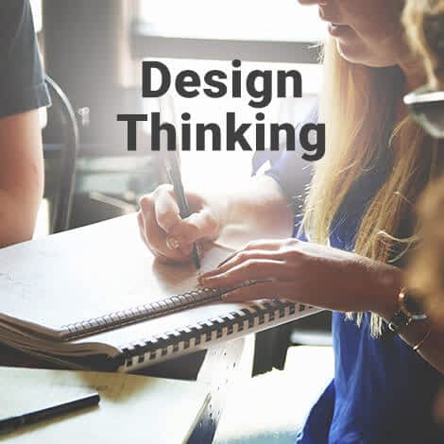](https://www.interaction-design.org/courses/design-thinking-the-beginner-s-guide)](https://www.interaction-design.org/courses/design-thinking-the-beginner-s-guide" \o "Design Thinking: The Beginner’s Guide)

[Design Thinking: The Beginner’s Guide](https://www.interaction-design.org/courses/design-thinking-the-beginner-s-guide" \o "Design Thinking: The Beginner’s Guide)

[ENROLLMENT CLOSES IN](https://www.interaction-design.org/courses/design-thinking-the-beginner-s-guide" \o "Design Thinking: The Beginner’s Guide)

**[5](https://www.interaction-design.org/courses/design-thinking-the-beginner-s-guide" \o "Design Thinking: The Beginner’s Guide)**

[days](https://www.interaction-design.org/courses/design-thinking-the-beginner-s-guide" \o "Design Thinking: The Beginner’s Guide)

[BOOKED](https://www.interaction-design.org/courses/design-thinking-the-beginner-s-guide" \o "Design Thinking: The Beginner’s Guide)

[View course](https://www.interaction-design.org/courses/design-thinking-the-beginner-s-guide" \o "Design Thinking: The Beginner’s Guide)

**GET WEEKLY UX INSIGHTS**

Join **202,976 designers** who get useful UX tips from our newsletter.

Top of Form

GO

Bottom of Form

**Make design better: share this article**

93

46

11

**WHAT YOU SHOULD READ NEXT**

[[](https://www.interaction-design.org/literature/article/5-stages-in-the-design-thinking-process)](https://www.interaction-design.org/literature/article/5-stages-in-the-design-thinking-process" \o "5 Stages in the Design Thinking Process)

**[5 Stages in the Design Thinking Process](https://www.interaction-design.org/literature/article/5-stages-in-the-design-thinking-process" \o "5 Stages in the Design Thinking Process)**

[Design Thinking is a design methodology that provides a solution-based approach to solving problems. It’s extremely useful in tackling complex problems that are ill-defined or unknown, by understanding the human needs involved, by re-framing the problem in human-centric ways, by creating many ideas in brainstorming sessions, and by adopting a ha...](https://www.interaction-design.org/literature/article/5-stages-in-the-design-thinking-process" \o "5 Stages in the Design Thinking Process)

* [170 SHARES](https://www.interaction-design.org/literature/article/5-stages-in-the-design-thinking-process" \o "5 Stages in the Design Thinking Process)
* [1 MONTH AGO](https://www.interaction-design.org/literature/article/5-stages-in-the-design-thinking-process" \o "5 Stages in the Design Thinking Process)

[[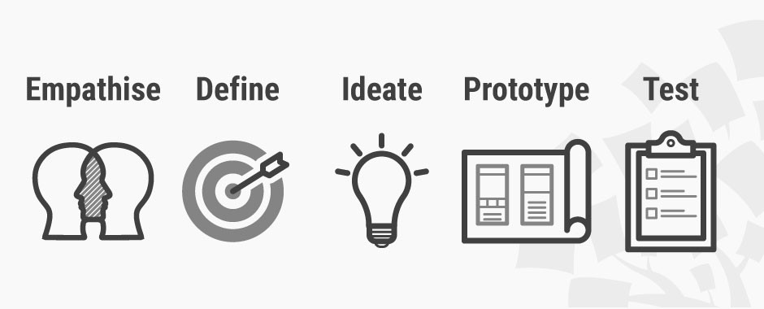](https://www.interaction-design.org/literature/article/what-is-design-thinking-and-why-is-it-so-popular)](https://www.interaction-design.org/literature/article/what-is-design-thinking-and-why-is-it-so-popular" \o "What is Design Thinking and Why Is It So Popular?)

**[What is Design Thinking and Why Is It So Popular?](https://www.interaction-design.org/literature/article/what-is-design-thinking-and-why-is-it-so-popular" \o "What is Design Thinking and Why Is It So Popular?)**

[Design Thinking is not an exclusive property of designers—all great innovators in literature, art, music, science, engineering, and business have practiced it. So, why call it Design Thinking? What’s special about Design Thinking is that designers’ work processes can help us systematically extract, teach, learn and apply these human-centered tec...](https://www.interaction-design.org/literature/article/what-is-design-thinking-and-why-is-it-so-popular" \o "What is Design Thinking and Why Is It So Popular?)

* [303 SHARES](https://www.interaction-design.org/literature/article/what-is-design-thinking-and-why-is-it-so-popular" \o "What is Design Thinking and Why Is It So Popular?)
* [4 WEEKS AGO](https://www.interaction-design.org/literature/article/what-is-design-thinking-and-why-is-it-so-popular" \o "What is Design Thinking and Why Is It So Popular?)

[[](https://www.interaction-design.org/literature/article/personas-why-and-how-you-should-use-them)](https://www.interaction-design.org/literature/article/personas-why-and-how-you-should-use-them" \o "Personas – A Simple Introduction)

**[Personas – A Simple Introduction](https://www.interaction-design.org/literature/article/personas-why-and-how-you-should-use-them" \o "Personas – A Simple Introduction)**

[Personas are fictional characters, which you create based upon your research in order to represent the different user types that might use your service, product, site, or brand in a similar way. Creating personas will help you to understand your users’ needs, experiences, behaviours and goals. Creating personas can help you step out of yourself....](https://www.interaction-design.org/literature/article/personas-why-and-how-you-should-use-them" \o "Personas – A Simple Introduction)

* [195 SHARES](https://www.interaction-design.org/literature/article/personas-why-and-how-you-should-use-them" \o "Personas – A Simple Introduction)
* [2 WEEKS AGO](https://www.interaction-design.org/literature/article/personas-why-and-how-you-should-use-them" \o "Personas – A Simple Introduction)

[[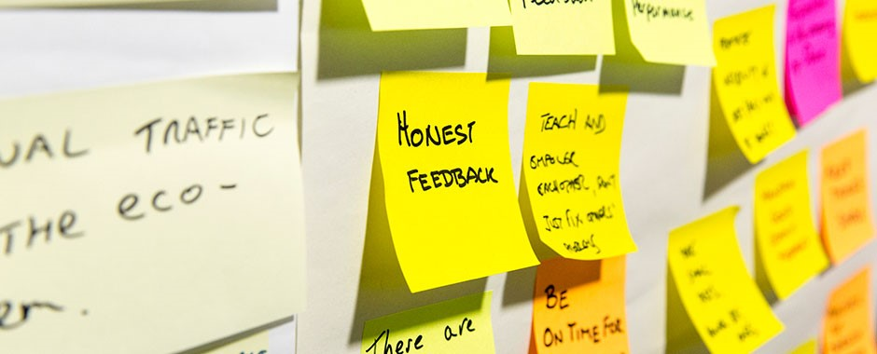](https://www.interaction-design.org/literature/article/stage-2-in-the-design-thinking-process-define-the-problem-and-interpret-the-results)](https://www.interaction-design.org/literature/article/stage-2-in-the-design-thinking-process-define-the-problem-and-interpret-the-results" \o "Stage 2 in the Design Thinking Process: Define the Problem and Interpret the Results)

**[Stage 2 in the Design Thinking Process: Define the Problem and Interpret the Results](https://www.interaction-design.org/literature/article/stage-2-in-the-design-thinking-process-define-the-problem-and-interpret-the-results" \o "Stage 2 in the Design Thinking Process: Define the Problem and Interpret the Results)**

[An integral part of the Design Thinking process is the definition of a meaningful and actionable problem statement, which the design thinker will focus on solving. This is perhaps the most challenging part of the Design Thinking process, as the definition of a problem (also called a design challenge) will require you to synthesise your observati...](https://www.interaction-design.org/literature/article/stage-2-in-the-design-thinking-process-define-the-problem-and-interpret-the-results" \o "Stage 2 in the Design Thinking Process: Define the Problem and Interpret the Results)

* [537 SHARES](https://www.interaction-design.org/literature/article/stage-2-in-the-design-thinking-process-define-the-problem-and-interpret-the-results" \o "Stage 2 in the Design Thinking Process: Define the Problem and Interpret the Results)
* [4 MONTHS AGO](https://www.interaction-design.org/literature/article/stage-2-in-the-design-thinking-process-define-the-problem-and-interpret-the-results" \o "Stage 2 in the Design Thinking Process: Define the Problem and Interpret the Results)

[[](https://www.interaction-design.org/literature/article/what-is-ideation-and-how-to-prepare-for-ideation-sessions)](https://www.interaction-design.org/literature/article/what-is-ideation-and-how-to-prepare-for-ideation-sessions" \o "What is Ideation – and How to Prepare for Ideation Sessions)

**[What is Ideation – and How to Prepare for Ideation Sessions](https://www.interaction-design.org/literature/article/what-is-ideation-and-how-to-prepare-for-ideation-sessions" \o "What is Ideation – and How to Prepare for Ideation Sessions)**

[Ideation is the process where you generate ideas and solutions through sessions such as Sketching, Prototyping, Brainstorming, Brainwriting, Worst Possible Idea, and a wealth of other ideation techniques. Ideation is also the third stage in the Design Thinking process. Although many people might have experienced a “brainstorming” session before,...](https://www.interaction-design.org/literature/article/what-is-ideation-and-how-to-prepare-for-ideation-sessions" \o "What is Ideation – and How to Prepare for Ideation Sessions)

* [539 SHARES](https://www.interaction-design.org/literature/article/what-is-ideation-and-how-to-prepare-for-ideation-sessions" \o "What is Ideation – and How to Prepare for Ideation Sessions)
* [2 YEARS AGO](https://www.interaction-design.org/literature/article/what-is-ideation-and-how-to-prepare-for-ideation-sessions" \o "What is Ideation – and How to Prepare for Ideation Sessions)

[[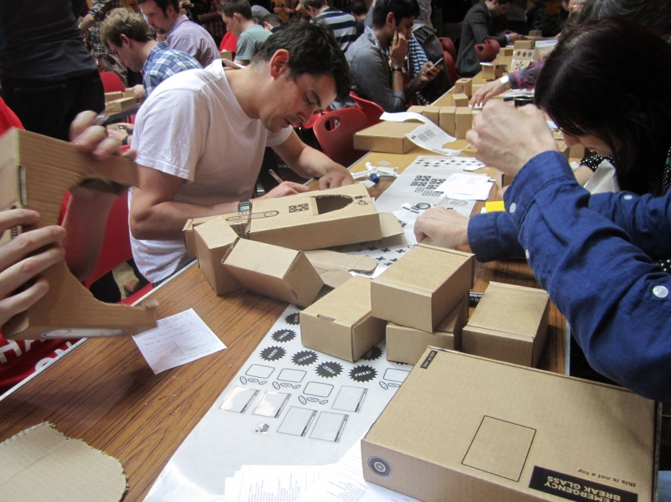](https://www.interaction-design.org/literature/article/stage-4-in-the-design-thinking-process-prototype)](https://www.interaction-design.org/literature/article/stage-4-in-the-design-thinking-process-prototype" \o "Stage 4 in the Design Thinking Process: Prototype)

**[Stage 4 in the Design Thinking Process: Prototype](https://www.interaction-design.org/literature/article/stage-4-in-the-design-thinking-process-prototype" \o "Stage 4 in the Design Thinking Process: Prototype)**

[One of the best ways to gain insights in a Design Thinking process is to carry out some form of prototyping. This method involves producing an early, inexpensive, and scaled down version of the product in order to reveal any problems with the current design. Prototyping offers designers the opportunity to bring their ideas to life, test the prac...](https://www.interaction-design.org/literature/article/stage-4-in-the-design-thinking-process-prototype" \o "Stage 4 in the Design Thinking Process: Prototype)

* [407 SHARES](https://www.interaction-design.org/literature/article/stage-4-in-the-design-thinking-process-prototype" \o "Stage 4 in the Design Thinking Process: Prototype)
* [1 YEAR AGO](https://www.interaction-design.org/literature/article/stage-4-in-the-design-thinking-process-prototype" \o "Stage 4 in the Design Thinking Process: Prototype)

[[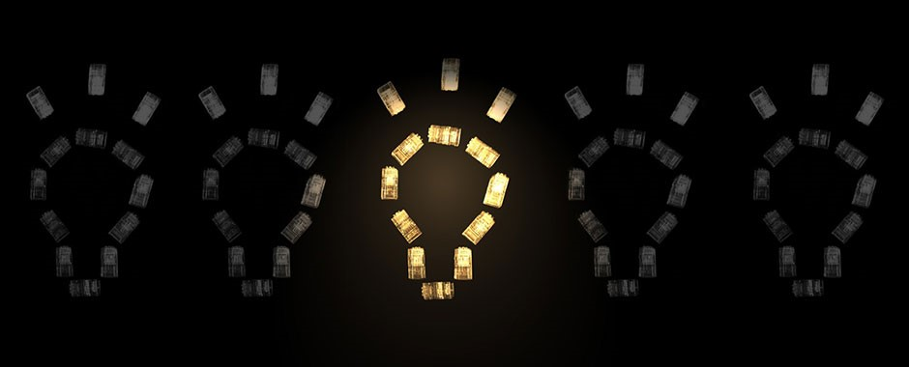](https://www.interaction-design.org/literature/article/stage-3-in-the-design-thinking-process-ideate)](https://www.interaction-design.org/literature/article/stage-3-in-the-design-thinking-process-ideate" \o "Stage 3 in the Design Thinking Process: Ideate)

**[Stage 3 in the Design Thinking Process: Ideate](https://www.interaction-design.org/literature/article/stage-3-in-the-design-thinking-process-ideate" \o "Stage 3 in the Design Thinking Process: Ideate)**

[In the Ideation stage, design thinkers spark off ideas — in the form of questions and solutions — through creative and curious activities such as Brainstorms and Worst Possible Idea. In this article, we’ll introduce you to some of the best Ideation methods and guidelines that help facilitate successful Ideation sessions and encourage active part...](https://www.interaction-design.org/literature/article/stage-3-in-the-design-thinking-process-ideate" \o "Stage 3 in the Design Thinking Process: Ideate)

* [344 SHARES](https://www.interaction-design.org/literature/article/stage-3-in-the-design-thinking-process-ideate" \o "Stage 3 in the Design Thinking Process: Ideate)
* [5 MONTHS AGO](https://www.interaction-design.org/literature/article/stage-3-in-the-design-thinking-process-ideate" \o "Stage 3 in the Design Thinking Process: Ideate)

[[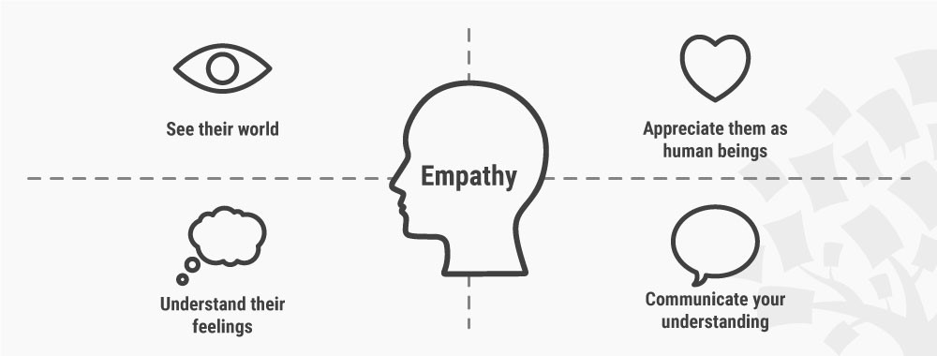](https://www.interaction-design.org/literature/article/stage-1-in-the-design-thinking-process-empathise-with-your-users)](https://www.interaction-design.org/literature/article/stage-1-in-the-design-thinking-process-empathise-with-your-users" \o "Stage 1 in the Design Thinking Process: Empathise with Your Users)

**[Stage 1 in the Design Thinking Process: Empathise with Your Users](https://www.interaction-design.org/literature/article/stage-1-in-the-design-thinking-process-empathise-with-your-users" \o "Stage 1 in the Design Thinking Process: Empathise with Your Users)**

[Design Thinking cannot begin without a deeper understanding of the people you are designing for. In order to gain those insights, it is important for you as a design thinker to empathize with the people you’re designing for so that you can understand their needs, thoughts, emotions and motivations. The good news is that you have a wide range of ...](https://www.interaction-design.org/literature/article/stage-1-in-the-design-thinking-process-empathise-with-your-users" \o "Stage 1 in the Design Thinking Process: Empathise with Your Users)

* [341 SHARES](https://www.interaction-design.org/literature/article/stage-1-in-the-design-thinking-process-empathise-with-your-users" \o "Stage 1 in the Design Thinking Process: Empathise with Your Users)
* [3 WEEKS AGO](https://www.interaction-design.org/literature/article/stage-1-in-the-design-thinking-process-empathise-with-your-users" \o "Stage 1 in the Design Thinking Process: Empathise with Your Users)

[[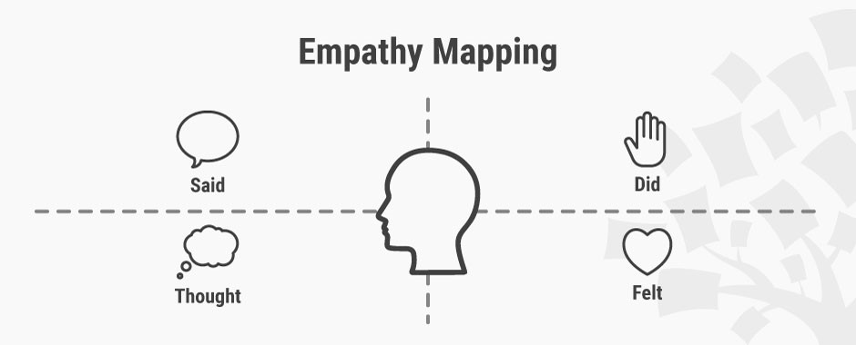](https://www.interaction-design.org/literature/article/empathy-map-why-and-how-to-use-it)](https://www.interaction-design.org/literature/article/empathy-map-why-and-how-to-use-it" \o "Empathy Map – Why and How to Use It)

**[Empathy Map – Why and How to Use It](https://www.interaction-design.org/literature/article/empathy-map-why-and-how-to-use-it" \o "Empathy Map – Why and How to Use It)**

[Did you know that users are more likely to choose, buy and use products that meet their needs as opposed to products that just meet their wants? An Empathy map will help you understand your user’s needs while you develop a deeper understanding of the persons you are designing for. There are many techniques you can use to develop this kind of emp...](https://www.interaction-design.org/literature/article/empathy-map-why-and-how-to-use-it" \o "Empathy Map – Why and How to Use It)

* [156 SHARES](https://www.interaction-design.org/literature/article/empathy-map-why-and-how-to-use-it" \o "Empathy Map – Why and How to Use It)
* [2 WEEKS AGO](https://www.interaction-design.org/literature/article/empathy-map-why-and-how-to-use-it" \o "Empathy Map – Why and How to Use It)

[[](https://www.interaction-design.org/literature/article/design-thinking-getting-started-with-empathy)](https://www.interaction-design.org/literature/article/design-thinking-getting-started-with-empathy" \o "Design Thinking: Getting Started with Empathy)

**[Design Thinking: Getting Started with Empathy](https://www.interaction-design.org/literature/article/design-thinking-getting-started-with-empathy" \o "Design Thinking: Getting Started with Empathy)**

[Empathy is an important element in Design Thinking and Human-Centred Design. What is empathy exactly? Why is empathy so important to designing solutions that actually work for people? Here, we’ll not only look at what](https://www.interaction-design.org/literature/article/design-thinking-getting-started-with-empathy" \o "Design Thinking: Getting Started with Empathy)